Exercise 1: Control Structures

Scenario 1: The bank wants to apply a discount to loan interest rates for customers above 60 years old.
Question: Write a PL/SQL block that loops through all customers, checks their age, and if they are above 60, apply a 1% discount to their current loan interest rates.

SET SERVEROUTPUT ON
DECLARE
v_age NUMBER;
BEGIN
FOR c IN (SELECT CustomerID, Name, DOB FROM Customers) LOOP
-- Calculate age
v_age := TRUNC(MONTHS_BETWEEN(SYSDATE, c.DOB) / 12);

IF v_age > 60 THEN
DBMS_OUTPUT.PUT_LINE('Customer: ' || c.Name || ' (Age: ' || v_age || ') - Eligible for discount');
-- Update loan interest
UPDATE Loans
SET InterestRate = InterestRate - 1
WHERE CustomerID = c.CustomerID;

DBMS_OUTPUT.PUT_LINE('→ Loan interest rate updated for Customer ID: ' || c.CustomerID);
ELSE
DBMS_OUTPUT.PUT_LINE('Customer: ' || c.Name || ' (Age: ' || v_age || ') - Not eligible');
END IF;
END LOOP;

COMMIT;
END;
/

OUTPUT:
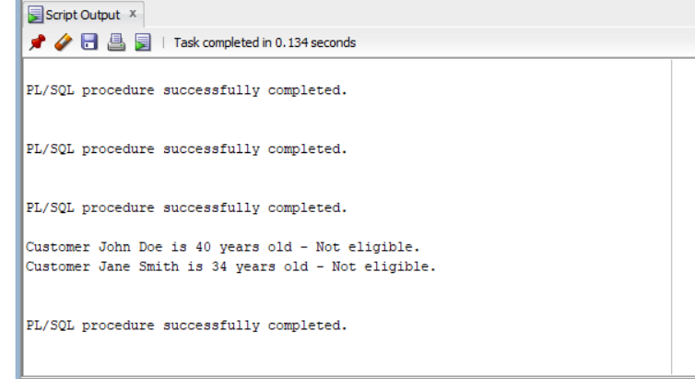
Scenario 2: A customer can be promoted to VIP status based on their balance.
Question: Write a PL/SQL block that iterates through all customers and sets a flag IsVIP to TRUE for those with a balance over $10,000.
SET SERVEROUTPUT ON;

BEGIN
FOR c IN (SELECT CustomerID, Name, Balance FROM Customers) LOOP
IF c.Balance > 10000 THEN
UPDATE Customers
SET IsVIP = 'TRUE'
WHERE CustomerID = c.CustomerID;

DBMS_OUTPUT.PUT_LINE('Customer ' || c.Name || ' is now a VIP!');
ELSE
UPDATE Customers
SET IsVIP = 'FALSE'
WHERE CustomerID = c.CustomerID;

DBMS_OUTPUT.PUT_LINE('Customer ' || c.Name || ' is NOT a VIP.');
END IF;
END LOOP;

COMMIT;
END;
/

OUTPUT:
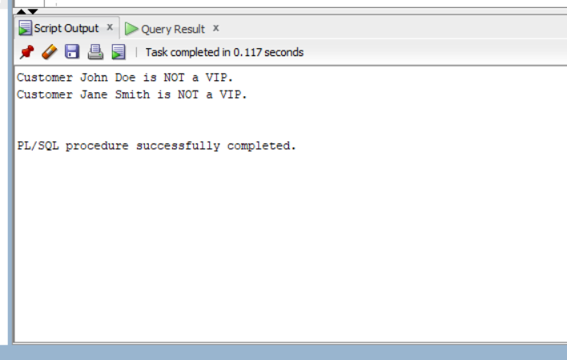

Scenario 3: The bank wants to send reminders to customers whose loans are due within the next 30 days.
Question: Write a PL/SQL block that fetches all loans due in the next 30 days and prints a reminder message for each customer.

SET SERVEROUTPUT ON;

BEGIN
FOR loan IN (
SELECT l.LoanID, l.CustomerID, l.EndDate, c.Name
FROM Loans l
JOIN Customers c ON l.CustomerID = c.CustomerID
WHERE l.EndDate BETWEEN SYSDATE AND SYSDATE + 30
) LOOP
DBMS_OUTPUT.PUT_LINE('Reminder: Customer ' || loan.Name ||
' (Customer ID: ' || loan.CustomerID || ')' ||
' has a loan (Loan ID: ' || loan.LoanID || ') due on ' ||
TO_CHAR(loan.EndDate, 'DD-MON-YYYY') || '.');
END LOOP;
END;
/

OUTPUT:
